Software Requirements Specification:

GROUP 7:

Content Moderation Pipeline Simulator

Course: CS1207 Object Oriented Programming Lab
Group: VII
Project Owner: <TA name>
Team member | Roll # | Role
<Team Lead> | <Roll #> | Team Lead
<Name> | <Roll #> | Member
<Name> | <Roll #> | Member
<Name> | <Roll #> | Member
Version: 1.0

Version | Primary author(s) | Description | Date completed
Draft 1.0 | All team members | First complete draft of the SRS | 15/10/2026

1 Introduction
The Content Moderation Pipeline Simulator (CMPS) is a desktop application that shows how a platform automatically flags harmful posts before a human moderator sees them. This section states why the document exists, what the product covers, and the terms and conventions used in the rest of the SRS.

1.1 Document Purpose
This SRS specifies the software requirements for CMPS, version 1.0. It describes the whole system, covering content submission, the automated moderation pipeline, the human review queue, and the appeals process, and it is the single reference for design, implementation and testing.
The document is written for the development team, the project owner (TA) and the course evaluators. It states what the system must do. Class-level design is described in a separate design document, though Section 5 lists the object-oriented design requirements the system must satisfy.

1.2 Product Scope
CMPS is a content moderation system for a chat-style platform. Users submit text posts or images. Each item passes through a chain of moderation rules in a Java application. The rules look for promotional spam and scams, phishing and fake system UIs, and toxic or harassing language. The machine-learning models run in a separate Python inference service that the Java application calls over a REST interface. Items are automatically approved, flagged for human review, or rejected. Flagged items wait in a review queue where a moderator makes the final call, and users can appeal a rejection.
Text moderation uses a two-tier design: a fast rule-based tier that catches known scams, abusive phrases and URL shorteners, followed by a fine-tuned DistilRoBERTa toxicity model. Image moderation covers three categories: promotional spam and scam flyers, phishing screenshots and fake system alerts, and harassment delivered as text inside memes. An image classifier recognises the type of image, OCR extracts any text in it, and the text models judge that text. The two results are combined into one decision. Explicit imagery is out of scope.
Benefits and goals:
- Combines automated filtering with human review, so clear cases are handled instantly and uncertain cases reach a person.
- Catches harmful text that is hidden inside images or disguised with character tricks (spaced letters, leetspeak, lookalike characters).
- Blocks automatically only at high-confidence thresholds tuned for 90% or better precision, and sends everything uncertain to review.
- Provides a configurable, extensible Java pipeline: new rules, content types, classifiers and score-combination strategies can be added without changing existing code.
- Gives the team a worked example of inheritance, polymorphism, interfaces, and the Chain of Responsibility and Strategy design patterns.
Term | Meaning
Aggregator | Component that combines the results of all rules and models into one ModerationDecision (a Strategy: maximum, weighted or rule-based).
Appeal | A user's request to re-examine a rejected item; moves through the states Submitted, Under Review, Upheld, Overturned.
Chain of Responsibility | Design pattern where a request passes along a linked series of handlers, each of which may act on it or pass it on.
Classifier | Interface for any ML model that returns scores or class probabilities for content.
CMPS | Content Moderation Pipeline Simulator, the product specified here.
Content | Abstract base class for anything a user submits; specialised as TextContent and ImageContent.
DistilRoBERTa | Small transformer language model (distilroberta-base) that is fine-tuned here for toxicity detection.
Fast path (Tier 1) | Rule-based first stage that applies compiled regular expressions to normalised text.
Inference Service | Python REST service that hosts OCR, text normalisation, the text models and the image model.
Jigsaw | Jigsaw Toxic Comment Classification dataset, used to fine-tune the text model.
ML | Machine Learning.
Moderation Decision | Final automated verdict for an item: Approved, Flagged or Rejected, with a score and reasons.
Moderation Rule | Interface implemented by every rule in the pipeline.
Moderator | Human reviewer who works through the review queue and appeals.
MPS | Metal Performance Shaders, the Apple-silicon GPU back end of PyTorch.
OCR | Optical Character Recognition, extracting text from an image.
OOP | Object-Oriented Programming.
PR curve | Precision-Recall curve, used to choose decision thresholds.
REST | Representational State Transfer, the HTTP interface between the Java application and the Inference Service.
Review Queue | Priority-ordered list of flagged items awaiting human review.
Semantic tier (Tier 2) | Second stage that scores text with the fine-tuned DistilRoBERTa model; runs only if Tier 1 does not decide.
SRS | Software Requirements Specification.
UML | Unified Modeling Language.

1.3 Definitions, Acronyms and Abbreviations

1.4 Document Conventions
This document follows the IEEE SRS structure and the course template. Text is in Arial 11 pt, single spaced, with 1" margins. Requirement identifiers follow these conventions:
- Fn for functional requirements (F1, F2, …).
- Un for use cases (U1, U2, …).
- NFRn for non-functional requirements.
- Class and interface names are written in CamelCase (for example, ModerationRule). The word "shall" marks a mandatory requirement.

1.5 References and Acknowledgments
- IEEE Std 830-1998, Recommended Practice for Software Requirements Specifications.
- SRS template for CS1207, based on the template by Dr. Rob Pettit (GMU).
- Sample SRS: Mess Fee Management System (course-provided example).
- Gamma, Helm, Johnson, Vlissides, Design Patterns: Elements of Reusable Object-Oriented Software (Chain of Responsibility, Strategy).
- Jigsaw Toxic Comment Classification Challenge dataset (Kaggle).
- Sanh et al., DistilBERT, a distilled version of BERT (2019); distilroberta-base model card (Hugging Face).
- cardiffnlp Twitter-RoBERTa sentiment model (Hugging Face).
- EasyOCR documentation; PyTorch documentation (CUDA and MPS back ends).

2 Overall Description
CMPS is a new, self-contained application made of a Java moderation application and a Python inference service, which together take a user's post from submission to a final moderation outcome, with automation first and humans second.

2.1 Product Overview
Large platforms receive far more posts than humans can read. They run automated filters first and send only uncertain or high-risk items to human reviewers. CMPS implements that workflow end to end. It is a new product and does not replace an existing system.
The system has two deployable parts. The Java application holds the domain model and all workflow logic: content objects, the chain of moderation rules, the score aggregator, the review queue, appeals, accounts and the user interface. The Python Inference Service hosts the machine-learning components behind a REST interface: EasyOCR, the text normaliser, the Tier 1 regular-expression engine, the fine-tuned DistilRoBERTa toxicity model with a sentiment model for context, and an image classifier. The Java application treats the service as a set of pluggable classifiers.
Text follows a two-tier path. Tier 1 is a fast rule-based stage that catches known scams, hard-coded abusive phrases and URL shorteners on normalised text. Tier 2, the DistilRoBERTa model, runs only when Tier 1 does not decide. Images are handled by combining two signals: an image classifier that recognises what kind of image it is (promotional flyer, phishing or fake system UI, meme, or ordinary image), and the text models applied to the text that OCR extracts from it. For example, a harassment meme is flagged when the image is recognised as a meme and its text scores as toxic.
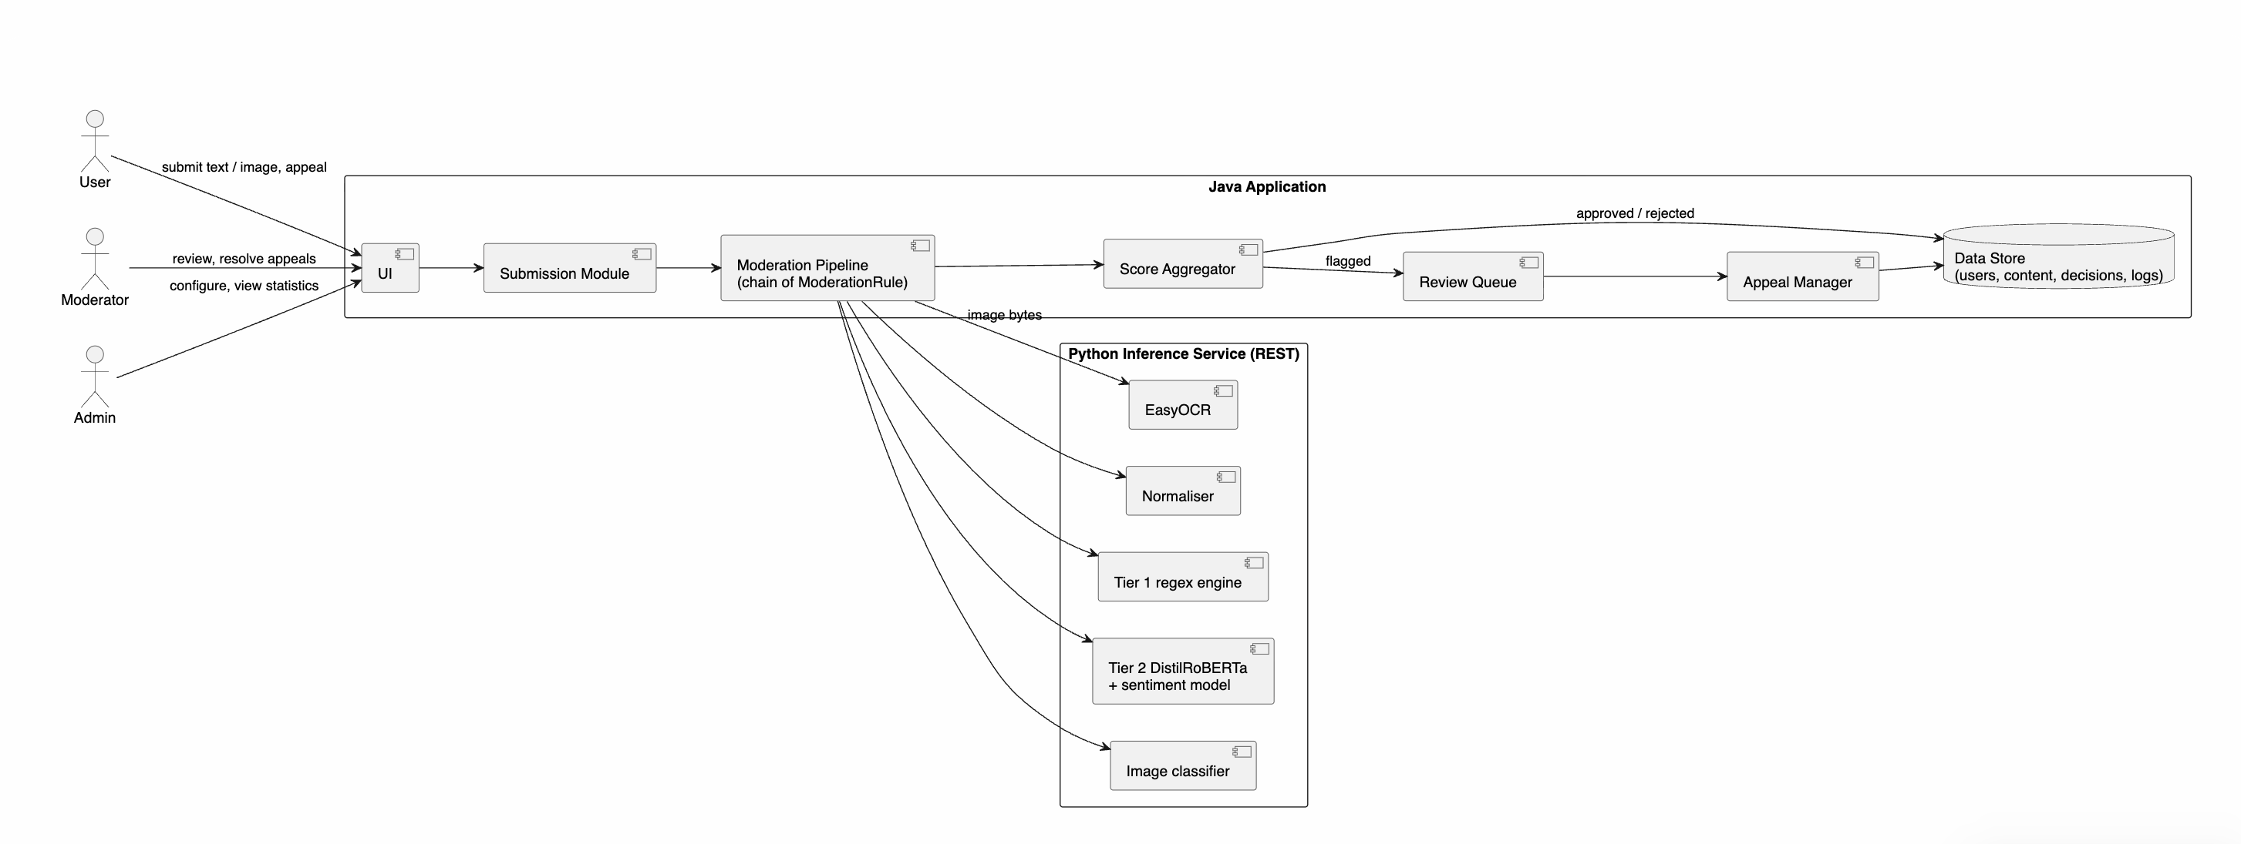
The diagram below shows the major components and external interfaces:

The main class design that the requirements assume:

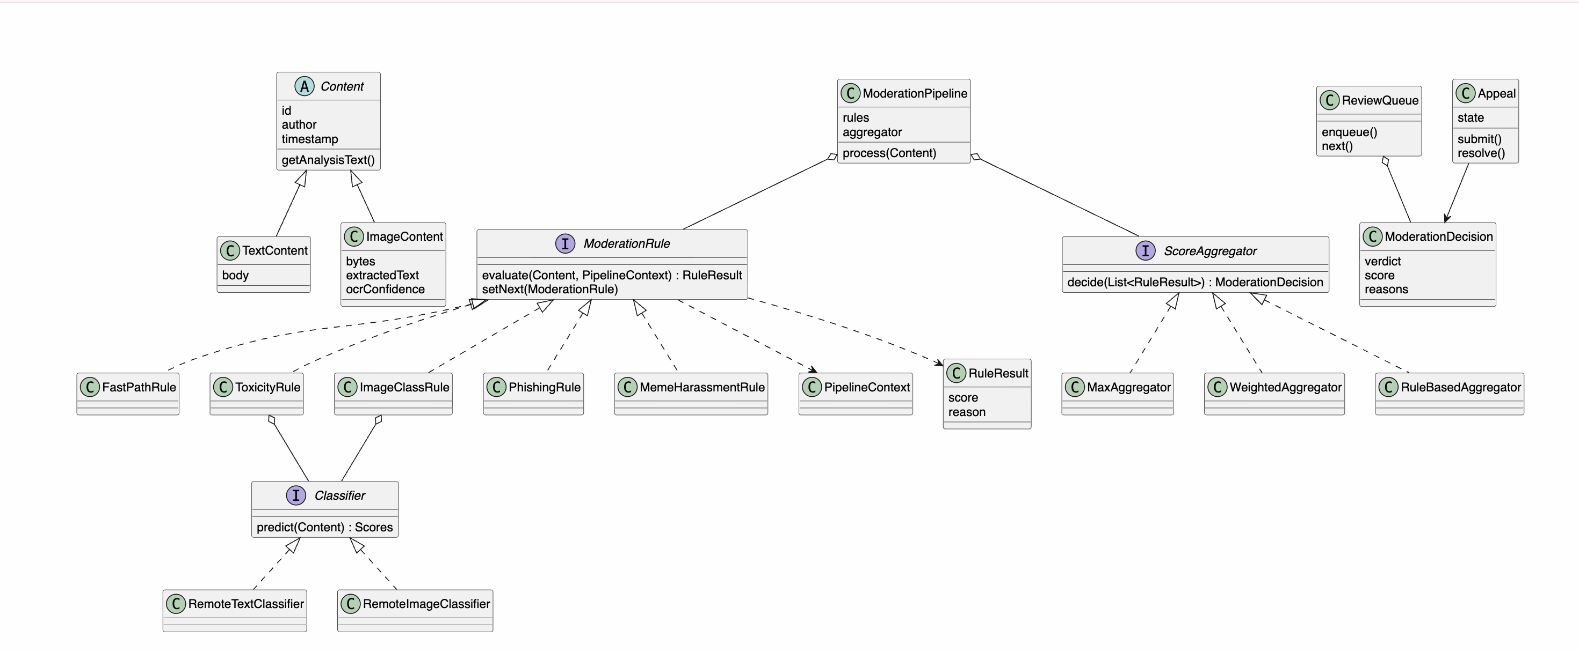

2.2 Product Functionality
- Login with role-based access (User, Moderator, Admin)
- Submit text and image content
- Normalise text to defeat evasion tricks
- Extract text from images (OCR)
- Run content through a configurable chain of moderation rules
- Fast-path detection of known scams, abusive phrases and URL shorteners
- Toxicity scoring with the fine-tuned DistilRoBERTa model
- Image classification (promotional flyer, phishing UI, meme, clean)
- Detect phishing and fake system UIs from image type and extracted text
- Detect harassment inside memes by combining image type and text toxicity
- Combine scores into an automated decision with reasons
- Maintain a priority-ordered review queue and let moderators act on it
- Check submission status and reasons
- Submit and resolve appeals
- Configure rules, thresholds and accounts (Admin)
- Audit log, batch evaluation and statistics

2.3 Design and Implementation Constraints
- OOP focus. The Java application shall use inheritance, polymorphism, interfaces and abstract classes, encapsulation and at least two design patterns (Chain of Responsibility and Strategy).
- Two components. The Java application and the Python service communicate only through a REST/JSON interface. The Java application shall not depend on any Python library directly.
- Python service. Python 3.11 with PyTorch. The service selects its compute device automatically: CUDA if available, otherwise Apple MPS, otherwise CPU.
- Text model. DistilRoBERTa (distilroberta-base) fine-tuned for multi-label classification (toxic, threat, insult, identity_hate) on a 70,000-row subset of the Jigsaw dataset. Decision thresholds come from precision-recall curves on a validation set.
- OCR. EasyOCR, called inside the Python service.
- Image model. A small pretrained vision network (for example MobileNetV3 or ResNet18, or CLIP embeddings with a light classifier) trained on a team-built dataset of safe images in the classes promo_flyer, phishing_ui, meme and other_clean.
- Content scope. Only the three agreed image categories are used. The datasets shall not contain explicit material.
- Environment. Runs on a standard lab PC or laptop with no GPU required, and uses a local database or files for storage.
- Team and schedule. Four members, one semester; features beyond Section 3 are out of scope.

2.4 Assumptions and Dependencies
- Users submit content in English.
- Images are PNG or JPG, at most 5 MB, and contain visible text where the category requires it.
- The Python Inference Service is running and reachable on the local machine before the Java application starts.
- The trained text model, the trained image model and the threshold settings are available before testing begins.
- The image training and test sets are generated by the team (for example, with Pillow) and cover the three categories plus clean negatives.
- User, Moderator and Admin accounts are created by the Admin.
- Multiple users may submit at the same time; the Java application processes submissions on a thread pool.

3 Specific Requirements

3.1 Functional Requirements
The system shall meet the fifteen functional requirements below. They expand the summary in Section 2.2.
ID | Requirement
F1 | The system shall provide a login page with role selection (User / Moderator / Admin), alert the person on a wrong password, lock the account temporarily after repeated failures, and let the person change their password.
F2 | The system shall let a User submit either a text post or an image (PNG/JPG, max 5 MB) and shall create a TextContent or ImageContent object accordingly, each with an ID, author and timestamp.
F3 | The system shall normalise text before analysis in this strict order: Unicode NFKC normalisation and lowercasing; removal of zero-width characters; Cyrillic-to-Latin homoglyph translation; collapsing of spaced letters (for example "f r e e" to "free") limited to single-space or dot delimiters; leetspeak translation applied only to mixed alphanumeric tokens; compression of runs of 3 or more repeated characters to 2.
F4 | The system shall extract text from every image using OCR, return the text with a confidence value, and then process that text exactly as a text post. If no readable text is found, the item shall be sent to review.
F5 | The system shall pass each item through a chain of ModerationRule objects in the configured order, where each rule returns a RuleResult (score and reason) and either passes the item to the next rule or ends the chain.
F6 | The system shall provide a fast-path rule (Tier 1) that matches normalised text against compiled patterns for known scams, hard-coded abusive phrases and URL shorteners, and returns an immediate block or review result; the semantic tier shall run only if this rule does not decide.
F7 | The system shall provide a toxicity rule (Tier 2) that scores text with the fine-tuned DistilRoBERTa model for the labels toxic, threat, insult and identity_hate, together with a sentiment score for context, and applies per-label thresholds: auto-block at or above the calibrated block threshold, review at or above 0.50.
F8 | The system shall provide an image rule that classifies each image as promo_flyer, phishing_ui, meme or other_clean and returns the class probabilities.
F9 | The system shall provide a phishing rule that detects fake login screens, fake virus alerts ("Your PC is infected!") and fake system warnings, by combining the image class phishing_ui with cue words, phone numbers and URLs found in the extracted text. It shall also flag promotional flyers (free followers, crypto giveaways, fake discount codes) by combining the promo_flyer class with the spam and scam patterns.
F10 | The system shall provide a meme harassment rule that flags an image when it is recognised as a meme and its extracted text scores as toxic, threatening, insulting or identity-based hate, using the same thresholds as text.
F11 | The system shall combine all rule results through a ScoreAggregator (maximum, weighted or rule-based, selectable) into one ModerationDecision (Approved, Flagged or Rejected) with an overall score and the list of triggered rules, and shall place every Flagged item in a priority-ordered ReviewQueue where a Moderator can approve, remove or escalate it with a note.
F12 | The system shall let a User view the status and reasons of their own submissions.
F13 | The system shall let a User appeal a Rejected item once, and shall move the Appeal through the states Submitted, Under Review, Upheld and Overturned, with a Moderator resolving it.
F14 | The system shall let an Admin create user accounts, enable or disable rules, reorder the chain, choose the aggregator and set the block and review thresholds.
F15 | The system shall record every automated and human action in an audit log, and shall let an Admin run a batch evaluation on a labelled dataset and view statistics (decisions per category and per rule, precision and recall, stage latencies, overturned appeals).

3.2 Use Case Model
The system has three human actors (User, Moderator, Admin), two system actors (Moderation Pipeline and Inference Service) and nine use cases.
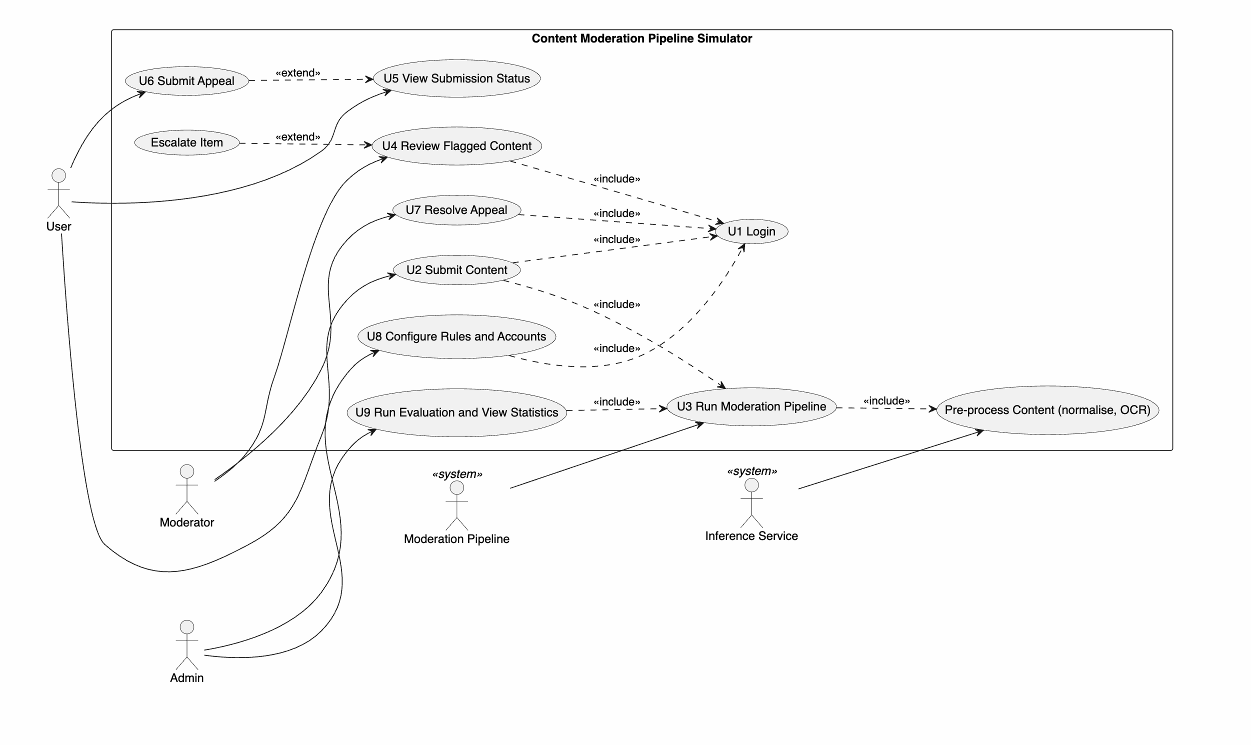
Relationships: U2, U4, U7 and U8 include Login (U1). U2 includes the pipeline run (U3), which includes pre-processing. Escalate Item extends U4 (only when the Moderator cannot decide). Submit Appeal extends View Submission Status (only when the item is Rejected and not yet appealed).

U1 Login
Field | Details
Author | <Team member 2>
Purpose | Authenticate a person and open the screen for their role.
Requirements Traceability | F1
Priority | High
Actors | User, Moderator, Admin
Preconditions | The account exists (created by the Admin).
Postconditions | A session is open for the role; a failed attempt is logged.
Extends | None
Includes | None
Basic Flow | 1. Person opens the login page and selects a role. 2. Person enters ID and password. 3. System verifies the credentials. 4. System opens the home screen for that role.
Alternative Flow | A1. Person chooses Change Password; the system verifies the current password and stores the new one.
Exceptions | E1. Wrong password: the system shows an alert and the attempts left. E2. After 3 failed attempts the account is locked for 5 minutes.
Notes / Issues | Passwords are stored as hashes (see 4.2).

U2 Submit Content
Field | Details
Author | <Team member 1>
Purpose | Let a User post text or an image into the moderation pipeline.
Requirements Traceability | F2, F3, F4
Priority | High
Actors | User
Preconditions | User is logged in.
Postconditions | A TextContent or ImageContent object exists and has been passed to the pipeline; the User sees a "received" message.
Extends | None
Includes | U1 Login, U3 Run Moderation Pipeline
Basic Flow | 1. User chooses Text or Image. 2. User types the text or selects the file. 3. System validates the input and creates the Content object. 4. System runs U3. 5. System shows the submission ID and its status.
Alternative Flow | A1. User cancels before submitting; nothing is stored.
Exceptions | E1. Empty text, unsupported file type or file over 5 MB: the system rejects the input with a message. E2. OCR fails: the item is sent to the review queue with the note "text could not be read".
Notes / Issues | Only the three agreed image categories are used in the test data.

Field | Details
Author | <Team member 1>
Purpose | Automatically score a submission with the chain of rules and models and produce a ModerationDecision.
Requirements Traceability | F3, F4, F5, F6, F7, F8, F9, F10, F11
Priority | High
Actors | Moderation Pipeline (system), Inference Service (system)
Preconditions | A Content object exists; at least one rule is enabled; the Inference Service is running.
Postconditions | The item has a ModerationDecision (Approved, Flagged or Rejected); Flagged items are in the review queue; the result and stage latencies are logged.
Extends | None
Includes | Pre-process Content (normalise, OCR)
Basic Flow | 1. System pre-processes the content: text is normalised, or an image is sent for OCR and its text is normalised. 2. FastPathRule (Tier 1) checks the text against the scam, abuse and URL patterns. 3. If Tier 1 has not decided, ToxicityRule (Tier 2) scores the text. 4. For images, ImageClassRule classifies the image, then PhishingRule and MemeHarassmentRule combine the image class with the text results. 5. The ScoreAggregator combines all RuleResults using the thresholds. 6. System stores the decision and, if Flagged, adds the item to the review queue.
Alternative Flow | A1. Tier 1 or any rule scores above the block threshold: the chain stops early and the item is Rejected. A2. OCR finds no readable text: the item is sent to review with the note "text could not be read".
Exceptions | E1. The Inference Service does not respond within the timeout: the item is sent to review and the failure is logged. E2. A rule throws an error: it is skipped and logged, and the remaining rules continue.
Notes / Issues | Rule order, thresholds and the aggregator are set in U8.

U3 Run Moderation Pipeline

U4 Review Flagged Content
Field | Details
Author | <Team member 4>
Purpose | Let a Moderator make the final decision on flagged items.
Requirements Traceability | F11
Priority | High
Actors | Moderator
Preconditions | Moderator is logged in; the review queue holds at least one item.
Postconditions | The item is Approved or Removed (or Escalated); the Moderator's note and the action are logged.
Extends | None (Escalate Item extends this use case)
Includes | U1 Login
Basic Flow | 1. Moderator opens the review queue (highest priority first). 2. Moderator opens an item and sees its content and triggered rules. 3. Moderator chooses Approve or Remove and writes a note. 4. System updates the item and removes it from the queue.
Alternative Flow | A1. Moderator chooses Escalate; the item moves to the Admin's queue with the note.
Exceptions | E1. The queue is empty: the system shows "No items to review". E2. Another Moderator already handled the item: the system refreshes the queue.
Notes / Issues | None

U5 View Submission Status
Field | Details
Author | <Team member 2>
Purpose | Let a User see the outcome and reasons for their own submissions.
Requirements Traceability | F12
Priority | Medium
Actors | User
Preconditions | User is logged in and has at least one submission.
Postconditions | None (read-only).
Extends | None
Includes | None
Basic Flow | 1. User opens My Submissions. 2. System lists items with status and date. 3. User opens an item to see the reasons given.
Alternative Flow | A1. User filters the list by status.
Exceptions | E1. No submissions: the system shows an empty-list message.
Notes / Issues | Reasons shown to the User are the rule names, not internal scores.

U6 Submit Appeal
Field | Details
Author | <Team member 2>
Purpose | Let a User contest a Rejected item.
Requirements Traceability | F13
Priority | Medium
Actors | User
Preconditions | The item is Rejected and has not been appealed before.
Postconditions | An Appeal object exists in the state Submitted; the item is linked to it.
Extends | U5 View Submission Status
Includes | None
Basic Flow | 1. From a Rejected item, User selects Appeal. 2. User writes a short explanation. 3. System creates the Appeal (state Submitted) and queues it for a Moderator.
Alternative Flow | A1. User cancels; no Appeal is created.
Exceptions | E1. The item was already appealed: the system blocks a second appeal. E2. Explanation is empty: the system asks for one.
Notes / Issues | One appeal per item keeps the simulation simple.

U7 Resolve Appeal
Field | Details
Author | <Team member 3>
Purpose | Let a Moderator uphold or overturn a rejection after an appeal.
Requirements Traceability | F13
Priority | Medium
Actors | Moderator
Preconditions | Moderator is logged in; an Appeal is in the state Submitted.
Postconditions | The Appeal is Upheld (rejection stays) or Overturned (item approved); the User can see the outcome; the action is logged.
Extends | None
Includes | U1 Login
Basic Flow | 1. Moderator opens the appeals list; the chosen Appeal moves to Under Review. 2. Moderator reads the content, the original reasons and the User's explanation. 3. Moderator selects Uphold or Overturn and adds a note. 4. System sets the final state and updates the item.
Alternative Flow | A1. Moderator leaves the Appeal Under Review for later.
Exceptions | E1. Moderator is the same person who made the original decision: the system routes the Appeal to a different Moderator.
Notes / Issues | Overturned appeals feed the false-positive count in U9.

U8 Configure Rules and Accounts
Field | Details
Author | <Team member 3>
Purpose | Let an Admin control how the pipeline behaves and who can use the system.
Requirements Traceability | F1, F14
Priority | High
Actors | Admin
Preconditions | Admin is logged in.
Postconditions | The rule chain, thresholds or accounts are updated and the change is logged.
Extends | None
Includes | U1 Login
Basic Flow | 1. Admin opens Settings. 2. Admin enables or disables a rule, reorders the chain, or edits thresholds. 3. Admin saves. 4. System rebuilds the chain with the new settings.
Alternative Flow | A1. Admin creates, edits or deactivates a User or Moderator account.
Exceptions | E1. Reject threshold lower than flag threshold, or every rule disabled: the system refuses to save and explains why.
Notes / Issues | Changes apply to new submissions only.

U9 Run Evaluation and View Statistics
Field | Details
Author | <Team member 4>
Purpose | Let an Admin run the pipeline on a labelled sample dataset and inspect the audit log and results.
Requirements Traceability | F15
Priority | Medium
Actors | Admin
Preconditions | Admin is logged in; a sample dataset (text and images with known labels) is loaded.
Postconditions | A statistics report is shown and can be saved; each run is logged.
Extends | None
Includes | U1 Login, U3 Run Moderation Pipeline
Basic Flow | 1. Admin selects a dataset and starts the run. 2. System passes each item through U3. 3. System compares decisions with the known labels. 4. System shows counts per decision and per rule, false positives, false negatives and overturned appeals.
Alternative Flow | A1. Admin opens the audit log and filters by date, actor or action.
Exceptions | E1. Dataset missing or malformed: the system shows an error and stops.
Notes / Issues | Statistics are computed from the labelled dataset chosen for the run.

4 Other Non-functional Requirements

4.1 Performance Requirements
ID | Requirement | Rationale
NFR1 | A text post of up to 2,000 characters shall receive a decision within 1 second on a CPU-only machine; Tier 1 decisions shall take under 50 ms. | Automated moderation must feel instant compared with human review.
NFR2 | An image of up to 5 MB, including OCR and image classification, shall receive a decision within 5 seconds on a CPU-only machine. | OCR and the image model are the slowest steps.
NFR3 | The review queue shall load within 2 seconds with up to 1,000 queued items. | Moderators work through long queues.
NFR4 | A batch evaluation of 500 items shall finish within 5 minutes. | Keeps testing and demonstration practical.
NFR5 | Automatic block thresholds shall be calibrated on a validation set (precision-recall curves) to give at least 90% precision per label. Items between the review threshold (0.50) and the block threshold shall go to human review. | Wrongly blocking users is costlier than sending an item to a moderator.
NFR6 | The Java application shall process at least 10 simultaneous submissions without errors or lost items. | Several users submit at once.
NFR7 | Adding a new ModerationRule, Content subclass, Classifier or ScoreAggregator shall require no change to existing rule classes. | Supports extensibility (open/closed principle).
NFR8 | The system shall run without a GPU; the Inference Service shall use CUDA or Apple MPS when available and fall back to CPU. | Team machines differ.

4.2 Safety and Security Requirements
- Access control. Each screen and action shall be limited to the roles that need it. Users cannot open the review queue, and Moderators cannot change rules.
- Credentials. Passwords shall be stored only as salted hashes, never in plain text. Accounts lock for 5 minutes after 3 failed attempts.
- Input validation. Only PNG and JPG files up to 5 MB are accepted. File content is checked, not only the extension, and text input is length-limited.
- Service interface. The Inference Service shall listen only on the local machine, validate request size and type, and be called with a timeout. The Java application shall never execute content it receives.
- Fail-safe behaviour. If the Inference Service or a model is unavailable, the item shall be sent to review and never auto-approved.
- Safe content scope. The datasets and the application shall not contain or process explicit imagery. Only the three agreed image categories are used.
- Harmful text handling. Toxic and harassing samples shall be kept in the data store only and shown only to Moderators and Admins, not to other Users.
- Audit trail. Every automated decision and human action shall be logged with actor, time, scores and reason. Log entries cannot be edited or deleted from the application.
- Fairness safeguards. Thresholds for threat and identity-based hate are set high so that automatic blocking is rare there; borderline items go to human review, and every rejection can be appealed once.
- Privacy. Only the data needed for moderation (author ID, content, decision) is stored. No real personal data shall be used in the datasets.

5 Other Requirements

5.1 Object-Oriented Design Requirements
The Content Moderation Pipeline Simulator (CMPS) is built on a strong object oriented foundation. The Java application applies the following concepts and design patterns, each of which maps to identifiable classes and interfaces in the code:
Concept | Where it appears
Inheritance and abstraction | Abstract class Content with subclasses TextContent and ImageContent.
Polymorphism | getAnalysisText() and pre-processing behave differently for text and images; every ModerationRule works on both through the same interface.
Interfaces | ModerationRule, Classifier and ScoreAggregator.
Chain of Responsibility | ModerationRule objects linked with setNext(), each deciding to act or pass on (FastPathRule, ToxicityRule, ImageClassRule, PhishingRule, MemeHarassmentRule).
Strategy | Swappable Classifier implementations (RemoteTextClassifier, RemoteImageClassifier) and swappable ScoreAggregator implementations (maximum, weighted, rule-based).
Encapsulation | ReviewQueue and Appeal keep their state private and change it only through methods (enqueue, next, submit, resolve).
Composition and aggregation | ModerationPipeline owns its rules and aggregator; ModerationDecision holds RuleResult objects.
Observer (optional) | ReviewQueue notifies the Moderator screen when new items arrive.
Multithreading | Submissions are processed on a thread pool with thread-safe queue access.
Exception handling | Custom exceptions for invalid input, OCR failure, service timeout and rule failure.

5.2 Testing and Documentation
- Each use case shall have at least one test case, and each rule shall be tested with at least 10 labelled samples (safe and unsafe).
- The evaluation report shall give precision, recall and stage latencies per category, an ablation of text normalisation, and a comparison of text-only against image-plus-text decisions on images.
- The final submission shall include the UML class diagram, the use case diagram, the REST interface description and a short user guide.

Appendix A - Activity Log
Date | Team member | Activity | Hours
15/10/2026 | All | Finalised the project idea and image categories (spam/scams, phishing/fake UIs, harassment memes) | <hrs>
<date> | <name> | <activity> | <hrs>

The Team Lead is responsible for keeping this log complete.

